**B. Analysis 2**

**1) Can you tell me No of Vehicles by Brand Available on ebay**

**for sale with the help of visualization**

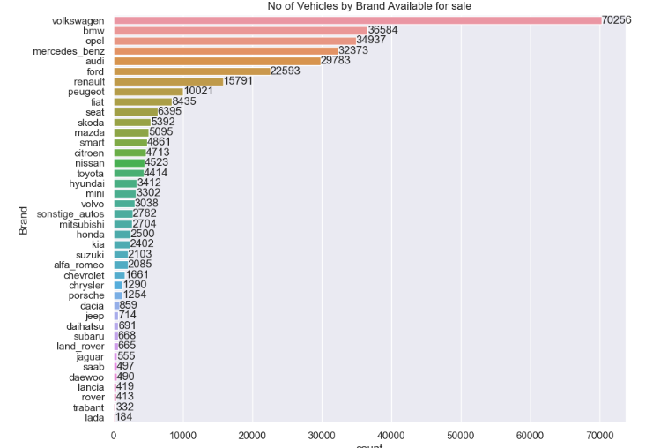

* “volkswagen” brand is available in wide range in “ebay used cars”, Germany , followed by ”bmw”,”opel”,”mercedes benz”.
* The least available brand is “lada”, second least is “trabant”

**2) What is the Average price for vehicles based on the type of vehicle as well as on the type of gearbox . Explain me with both numerical and visualization analysis.**

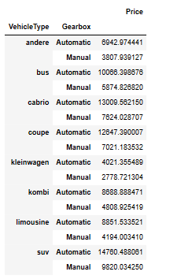

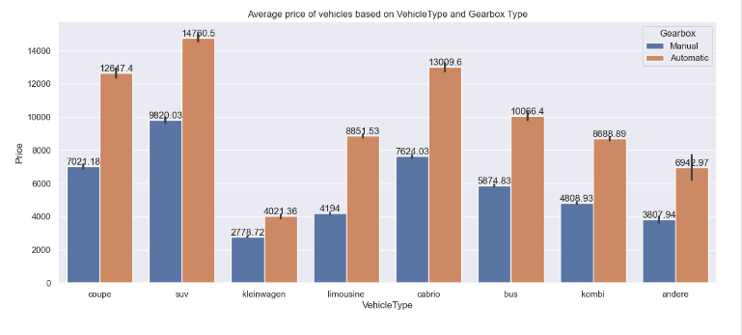

* As per the dataset, the vehicle type “suv” average price for “manual” gear box is 9620.03 and “automatic” gearbox is 14760.5 which is the highest average price among all other vehicletypes.
* Second place is occupied by “cabrio”.
* The last vehicle type is “kleinwagen” with the average price 3397.9 for “automatic” gear type and 2451.95 for “manual” gear type.
* From the plotting we can say that for any vehicle type the price for “Automatic” gear box vehicle is having a little more when compared to “manual” gear box vehicles.

**3) What is the marginal probability of private seller**

* The marginal probability of Private seller is 1.